**ANALYSIS INTERFACE – GETTING STARTED**

**Installations (one-time for each system):**

1. Install [R version 4.1.0](https://cran.r-project.org/bin/windows/base/old/) with all the default settings. Note the folder location where R gets installed (In Windows OS, it is usually C:\Program Files\R\<version name>)
2. Install [R tools](https://cran.r-project.org/bin/windows/Rtools/rtools40.html).
3. Install latest version of [R Studio](https://posit.co/products/open-source/rstudio/) (open source free version) with default settings
4. Download latest version of the [excel based survey analysis tool](https://github.com/adityendrasuman/survey-management/tree/main/01.%20TOOL) **(interface master.xlsm)**.
5. Open this excel file
   * If prompted “PROTECTED VIEW: …”, click **Enable Editing**
   * If prompted “SECURITY RISK: …”, then close the file > Right click on the file > Click on Properties > In General tab, **click Unblock**. Then open again

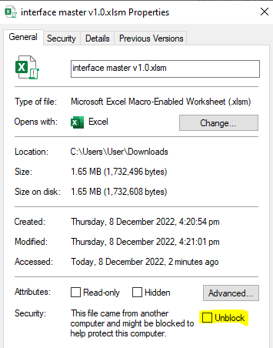

* + If prompted “SECURITY WARNING: Macros have been disabled”, click **Enable Content**

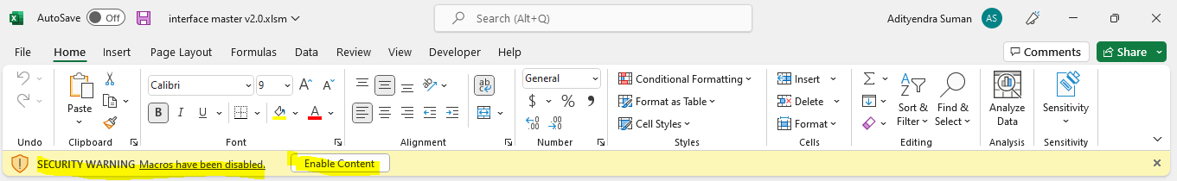

1. You will be prompted to update the yellow cell. Click OK > Browse and select location of the R installation (**RScript.exe**). It is usually located in C:\Program Files\R\<version name>\bin\Rscript.exe in Windows OS

1. You will be prompted with a message that says “Interface history not found. Reset?”. Click **Yes**
2. Doing this will set-up your tool and install a bunch of necessary R libraries automatically onto your system (will require ~15 mins). Installation is complete

**NOTE:** Do not close the dark cmd screens that automatically pop-up several times during the process. They will close on their own

**For each new project:** Repeat steps 4 – 7 from previous section.

This will create:

1. **Interface history** folder
2. **Latest R logs.txt**

**NOTE 1**: Interface history contains all the information needed to start a session from where the last session closed. Passing **interface master** file and **interface history** foldertogether will allow other team members to continue the analysis

**NOTE 2**: VERY IMPORTANT - Ensure that if it is placed in a shared folder (Dropbox or Onedrive), the Interface file is not being edited by multiple members simultaneously.